COLD ASHBY VILLAGE HALL
Main Street, Cold Ashby NN6 6EL
Charity number 1024816
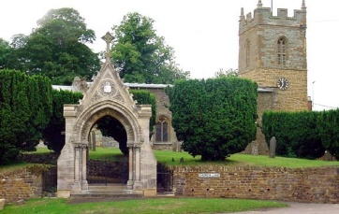
Committee Meeting Minutes

Tuesday 22nd May, 2018: 7.30 p.m.

Minutes

- Minutes of meeting on 20th February 2018 were approved.
- Matters arising: KG had not received calling papers. It was agreed that LG would pass on a calendar.
- Apologies for absence: RG, AT. (present: BB, GJ, ST, EG, RM, CS, RB)
- Chairman’s report: EG thanked for facilitating removal of rubbish at no cost.
- Finance:
- Monthly accounts February-May: noted and approved
- Activities and usage update:
- Luncheon club (CS): compensation of £40 agreed for late cancellation.
- Yoga sessions – opening in June: agreed tutor should use keysafe.
Discussions on keyholders revealed the following persons: BB,GJ,RB,CS,KG.
- Water pipe damage – increased water bill could be reclaimed in part. Sec to attempt. No bill for work received.

- Electricity issues. Sec reported switching problems with two lights and the return of the ‘tripping’ problem.

- Door replacement. Chairman had received quote for replacement doors.
It was agreed that a bid to the NCF be made for electrical and door replacement. Additional quote needed against specification for electrical work.

- Two additional items: water butt: GJ and RB to repair or replace. PC to be alerted to Billy lees bench condition.

G Jones, Secretary May 23 2018

